2.5 Polynomial Division and the Remainder Theorem
Polynomial Long Division can be used to divide by linear and nonlinear polynomials. It is similar to long division with real numbers.
Examples:
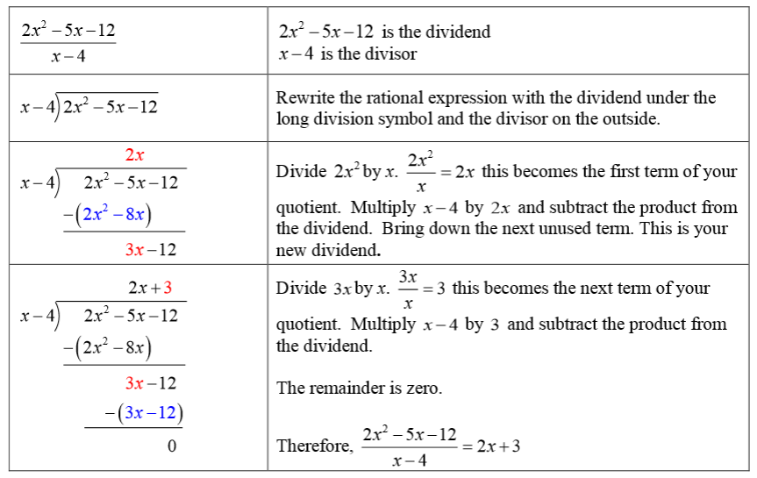
- Use polynomial long division to divide $\frac{2x^{2}-5x-12}{x-4}$

- $\frac{3x^{3}+5x^{2}+8x+7}{3x+2}$

- $(x^{2}-8x-16)÷(x+4)$

Synthetic division can be used to divide a polynomial by a linear polynomial
- To use synthetic division, the divisor must be of the form (x-a), where a is a real number.
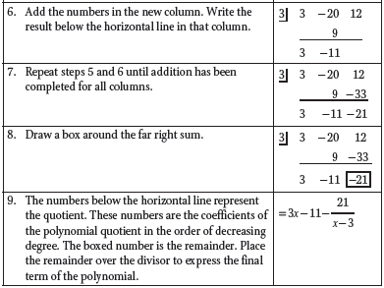
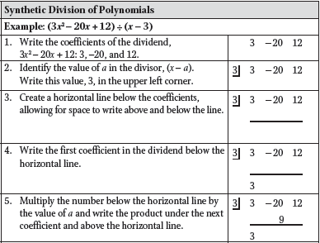
- Use the following steps to divide polynomials using synthetic division. An example has been provided for clarity.

- If the remainder is 0, then the divisor is a factor of the polynomial. This is called the remainder theorem
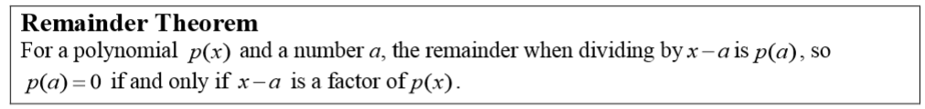
Examples:
- Find the quotient of $(x^{2}-5x-20)÷(x-4)$ 2. Find the quotient of $(x^{3}-8x+6)÷(x+5)$

- Is $\left(x+2\right)$ a factor of$(x^{2}-10x+11)$? 4. Is $\left(x-6\right)$ a factor of$(x^{2}-14x+48)$?

Synthetic division can also be used to find the value of a function. This is known as synthetic substitution.
- To evaluate a polynomial using synthetic substitution, follow the same process described for synthetic division. For example, given the function $3x^{2}-20x+12$, if you want to determine the value of the function at $x=3$, use 3 as the a value in the divisor of the synthetic division. The resulting remainder gives the value of the polynomial when evaluated at $x=3$.
Examples:
1. Evaluate $3x^{2}-20x+12$ at $x=3$. 2. Evaluate $x^{4}-x^{2}-32$ for $x=-7$.

- The amount of a certain medication remaining in the bloodstream t hours after taking the medicine is modeled by the equation $M\left(t\right)=-x^{3}+5x^{2}+3x+18$. Package directions recommend taking a second dose 4-6 hours after the initial dose. Use synthetic substitution to show that these directions are accurate.

