Math 3 - Law of Cosines Notes

C:\Users\teagan.mcarthur\AppData\Local\Microsoft\Windows\Temporary Internet Files\Content.IE5\SZPG5OYH\MC900423159[1].wmfRecall from Law of Sines, that the Law of Sines can be used to solve a triangle when an angle and it’s opposite side are given (i.e. A and a, B and b, or C and c). If an angle and it’s opposite side length are not given, we can use the Law of Cosines followed by the Law of Sines to solve the triangle. You would need to use the Law of Cosines when side-side-side (SSS), or side-angle-side (SAS) is given. Good news: If the Law of Cosines must be used to find the first missing piece of a triangle, then there is no ambiguous case to check for.

**\*\*\*When given SSS-Use Law of Cosines to find the largest angle first (the angle opposite the longest side)**

**\*\*\*When given SAS-Use Law of Cosines to find the side opposite the given angle, then use the Law of Sines to find the smaller angle of the two angles not given (this will be the angle opposite the shorter side given)**

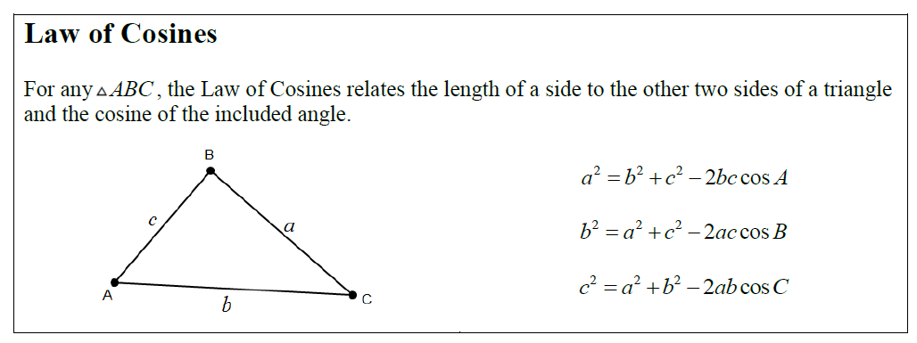

Example 1:

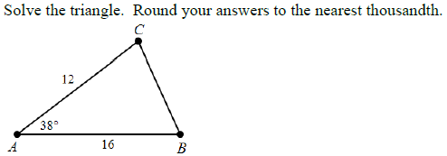

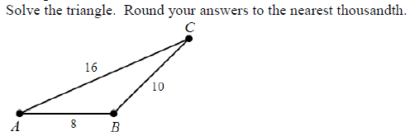

**Law of Sines and Law of Cosines Summary**

Law of Sines is used when Angle-Angle-Side, Angle-Side-Angle, or Side-Side-Angle is given

* Always check **SSA** for the possibility of a 2nd triangle.

Law of Cosines is used when Side-Side-Side or Side-Angle-Side is given

* When SSS or SAS is given, there is only one triangle that exists for the given sides and angles. However, the order in which you find the missing angles and sides sometimes matters (in obtuse triangles). It is safe to always follow these procedures:
  + If **SSS** are given, use Law of Cosines to find the **largest angle first**
  + If **SAS** are given, use Law of Cosines to find the side opposite the angle given, then use the Law of Sines to find the **smallest angle first**